**Furkan Karakaya** received the B.Eng. and M.Sc. degrees in Electrical and Electronics Engineering from Middle East Technical University, Ankara, Turkey, in 2017 and 2020, respectively. He is currently working toward the Ph.D. degree in Middle East Technical University as a member of the PowerLab Research Group. His research interests includes power electronics, characterization, applications and reliability of wide bandgap transistors, and integrated and fault tolerant electrical motor drivers.

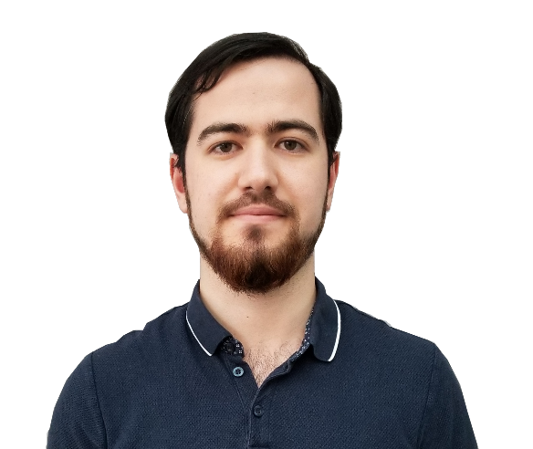

Furkan Karakaya

**Ozturk Sahin Alemdar** received the B.Eng. and M.Sc. degrees in Electrical and Electronics Engineering from Middle East Technical University, Ankara, Turkey, in 2013 and 2016, respectively. He is currently working toward the Ph.D. degree in Middle East Technical University as a member of the PowerLab Research Group. He has been with Aselsan Inc., Ankara, Turkey since 2013 where he is a Power Supply Design Engineer. His current research interests include wide-bandgap semiconductors, high frequency power converters and renewable energy.



Ozturk Sahin Alemdar

**Ozan Keysan** received the master’s degree from Middle East Technical University (METU), Ankara, Turkey, in 2008, and the Ph.D. degree from the University of Edinburgh, Edinburgh, Scotland, in 2014. He is currently an Assistant Professor with the Electrical and Electronics Engineering Department, METU. His current research interests include renewable energy, design, and optimization of electrical machines, smart grids, superconducting machines, and permanent-magnet machines.

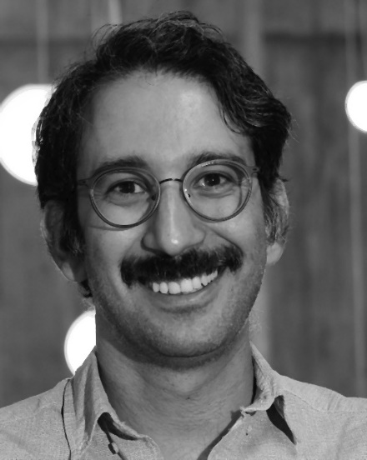

Ozan Keysan